Software Requirements Specification

For

SixComServices

Version 1.0 approved

Prepared by <Anna Rogojine

 Ziv Gimany

Moran Asulin

Elad Metodi

Alexander Borisenko

Shirel Biton

Ofek Logasi

Shay Manshrov

Sami Saliba

11.3.2018

# Introduction

## Purpose

The product covered in this SRS is SixComServices, a sales opportunities management system for SixCom’s sales department. SixComServices is meant to provide a solution to the ever growing customer base and sales force of SixCom that can no longer be documented efficiently with the tools used by SixCom currently, SixComServices solves this problem by creating an easily accessible and sortable database that allows tracking of the communication between customers and sales department employees, tracking of costumer history and storing all of the sales opportunities documentations.

The purpose of this document is to give a detailed description of the software, including its requirements, its different functions, its purpose, its features and the general direction for its design.

The SRS is meant to be mainly a declaration for the customer to approve but will also be used as a guideline for the development of the first version of the software by the development team.

## Document Conventions

The beginning of the document contains a table of contents.

Each chapter name is written in bold text of size 18 with the number of the chapter preceding it.

Each section name in a chapter is numbered and written in bold text of size 14.

Acronyms are written in all uppercase letters.

Every sentence begins with an uppercase letter.

S.O. stands for: Sales Opportunity.

## Intended Audience and Reading Suggestions

The intended audience for the document is mainly the customer and the initial development team but the document may be used by other readers such as project managers, testers, users and documentation writers.

The next section after this introduction contains a general description of the product which is relevant to all readers of this document. The user documentation is especially relevant to the users of the software as it contains help for users, other parts of the next section are mainly for the developers.

The third section contains external interface requirements going over the details that are relevant to the user interface including standards, style guides, characteristics of the interface, connections between software components and network server communication protocols.

User interface part of the third section is intended for the user and the developer alike while the rest

of the third section is mainly for the developer and the customer.

The fourth section of this document contains a list of the features the software provides, each feature in the list is given a description, a response sequence and the functional requirement for that feature. This section is mainly for the developers team and the customer but some users may find it useful as well.

Section five specifies the different requirement for the software such as performance requirements, safety requirements, security requirements, software quality attributes and business rules. Section five is meant to be a specification of all of the requirements that should be agreed on by both the customer and the developers team.

Section six includes any additional requirements not mentioned elsewhere in the document , it’s meant to be a guideline for developers.

The glossary section is meant for all readers of the document as it contains explanations for all the terms, acronyms and abbreviations used in the document.

The analysis models section contains diagrams that are relevant to the development process because of that this section is meant for the developers.

The “To Be Determined List” keeps track of all the TBD parts mentioned in the document, it’s meant for developers and project manager.

## Product Scope

SixComServices is a software meant to provide a comfortable, intuitive and efficient way to store and access clients’ information and S.O.s’ information which allows the employee to provide better service to the customer and have more resources directed towards the selling part of the deal instead of the documentation part. Also the software will create a history for each client which is meant to allow any employee to close a sale even if he wasn’t the one who spoke with the customer initially, this allows for higher flexibility in the workflow. Another utility the software provides is giving each employee a user profile that tracks his sales opportunities and client profiles he created, such tracking will significantly ease the managers’ work as it will provide the complete data for how well a certain employee performs.

SixComServices will be built to support the growth of the company by allowing expansion both in the number of employees and of customers.

# 2. Overall Description

**2.1    Product Perspective**

Our Company SIXCOM was created to streamline the customer service of a cellular company that sells cellular and surfing packages to many. In the past, the cellular company used manual documents, and as a result many customer requests were lost and were not answered.

Our company was designed to prevent such cases. The key components of the system include easy access to the service provider, entry to a customer card, presentation of past inquiries, and update of cellular and surfing packages.

The system is based on a connection to a web server and sits on an external server.

**2.2    Product Functions**

The Product function:

When the user (Sale representative OR Manager) enters the software he will need to login by entering id and password, after the login screen, he will have the option to

choose to insert (Client List, Client+, Deals, Opportunities).

Client List will show to the user all the clients that use our services.

Client+ will give to the user option to add clients

Deals will show us a list of all the deals that the company offer to clients.

Opportunities will show us all the clients that are potential to join to the company.

Manager Section: The manager have same entrance but another functions.

After the login he can choose to insert (Opportunity list, Employee List, Employee+, Change

activation status).

Employee list will show us all the employee list that work in company with their details.

Employee + will give to the manager option to add employee.

Opportunity list will show to the manager list of all the clients that are potential to join to the

company. Change activation status give to the manager list of clients and option to change the activation status(Active/Blocked).

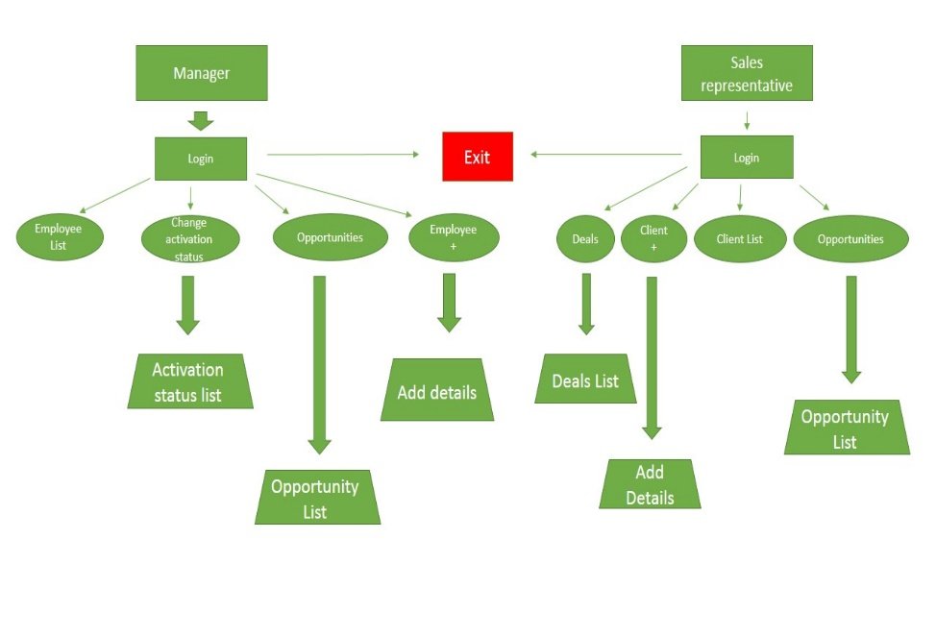

**2.3 User Classes and Characteristics**

There are two types of users that interact with the system: Manager, Sale representative.

Each of these two types of users has different use of the system so each of them has their own requirement.

The manager frequency of use the program will be less than the employee, since the employee will do most of the work, such as: customer absorption, customer retention, package offers, follow-up inquiries and more.

The manager will have other privileges, such as options to add employees, change customer status, and track after the employees and customer lists.

Engaging in a program requires basic computer skills, for the users that use the program.

The managers and employees they need to know all the features of the program well so they should be very satisfied with the program. Also, the sales team is expected to use the program frequently.

**2.4 Operating Environment**

The software will run on windows operating starting windows 7 and higher.

**2.5 Design and Implementation Constraints**

Internet connection is also a constraint for the system. Because it brings data from the database over the Internet, it is essential that there is an Internet connection for the system to function. This can be constraints for the employee trying to add clients or receive inquiries about new package updates, new promotions, and more, and for the manager who is trying to follow the employee / customer list, add employees and change treatment status.

**2.6 User Documentation**

All documentation will be made in accordance with the requirements relating to open source software under the GNU (General Purpose License).

In addition, the online user documentation will be in the form of software.

# External Interface Requirements

## User Interfaces

As the user opens the program a log in page will be presented

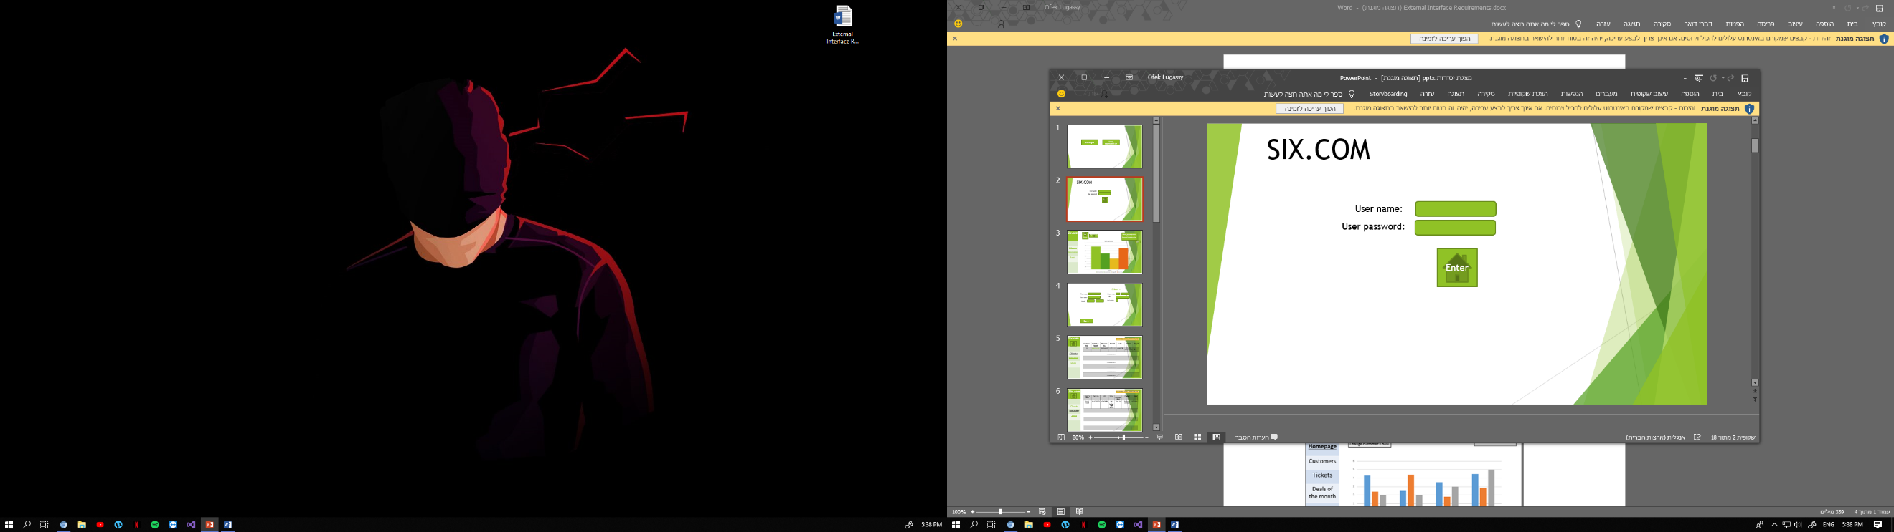

After the user logs in he will be moved to the first page of the program.

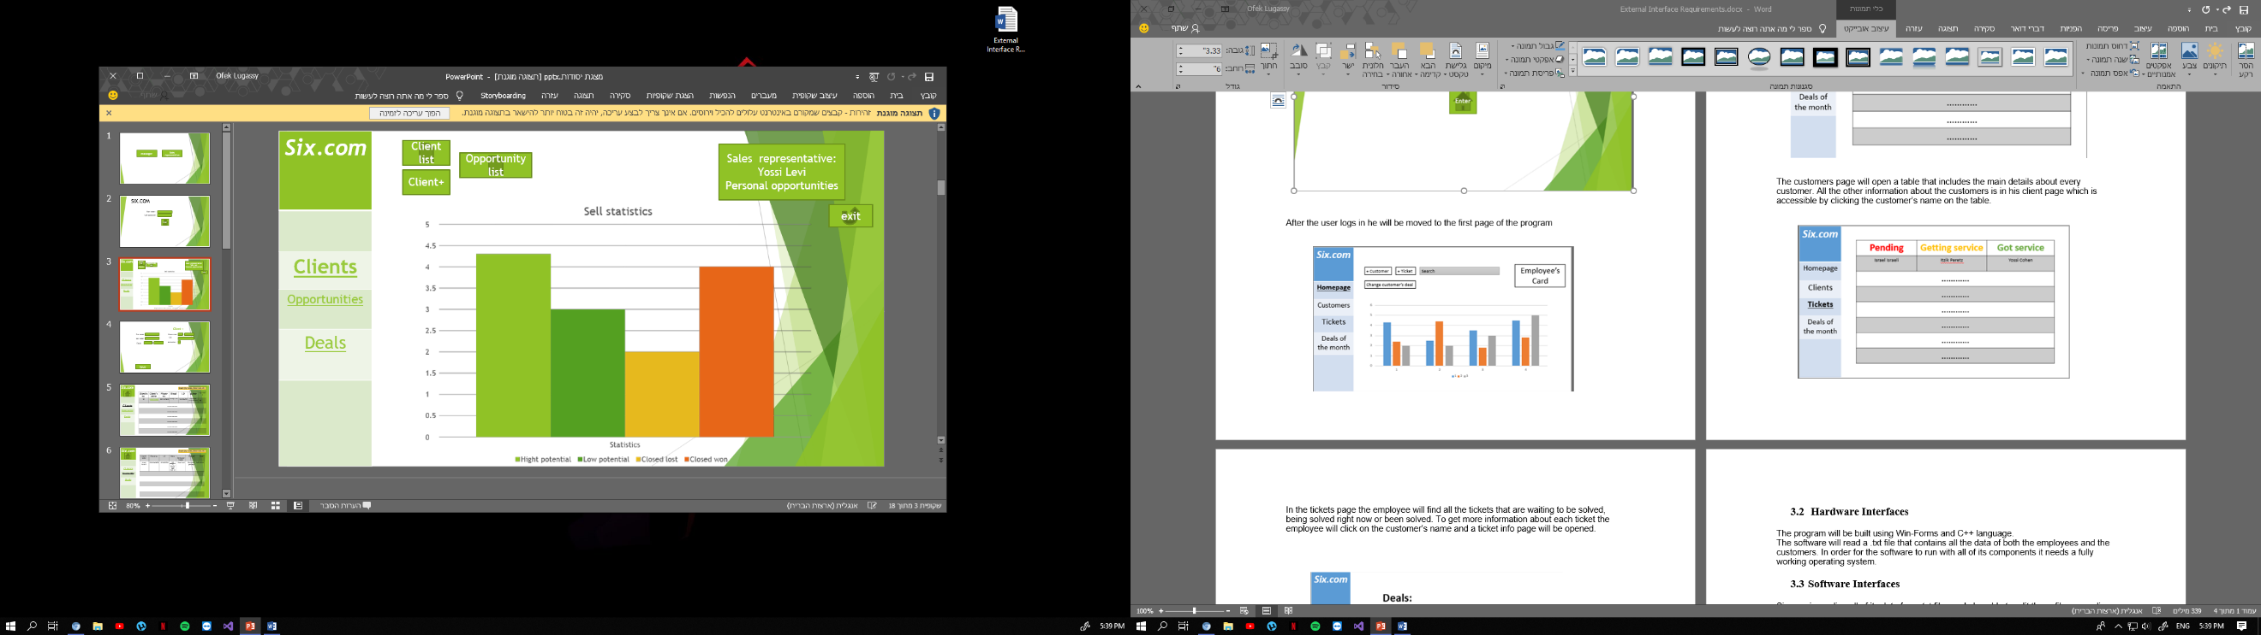

At this stage the employee can use several functions.

He can either add a new client or reach the clients or opportunities list.

Change the customer current deal and search a customer on the search bar in the top middle screen.

The employees card on the top right corner will show the employee’s details like his name, id etc.

The chart below will show details about the customers and the statistics of closed cases.

The navigation bar on the left will help the employee navigating between the sections of the program.

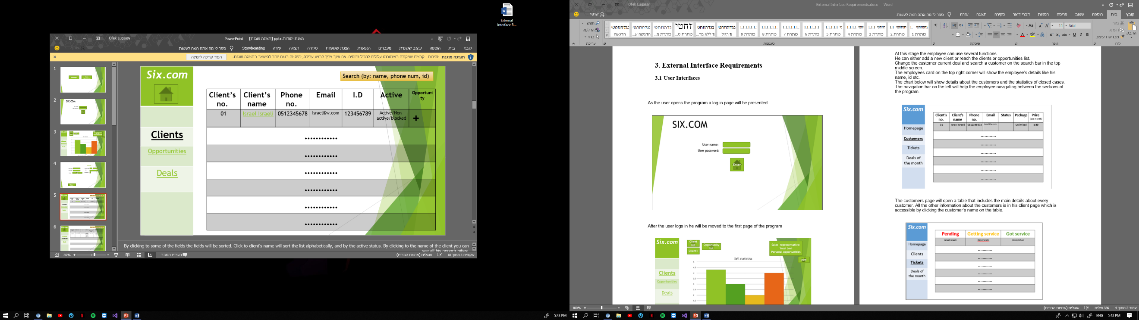

The customers page will open a table that includes the main details about every customer. All the other information about the customers is in his client page which is accessible by clicking the customer’s name on the table.

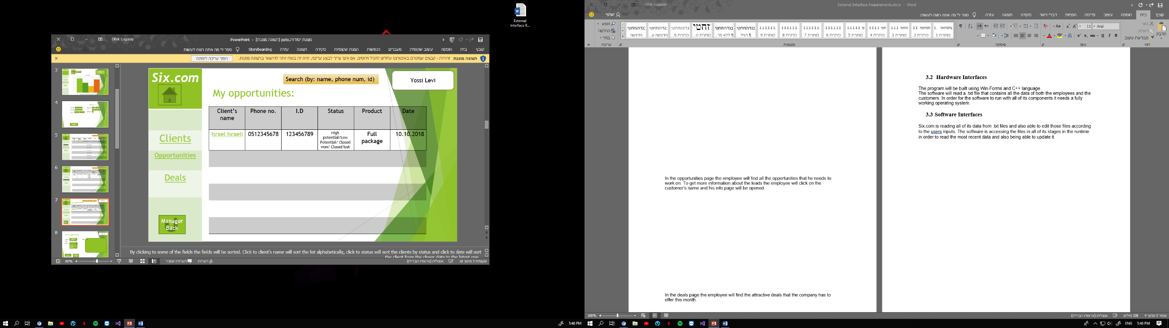

In the opportunities page the employee will find all the opportunities that he needs to work on. To get more information about the leads the employee will click on the customer’s name and his info page will be opened.

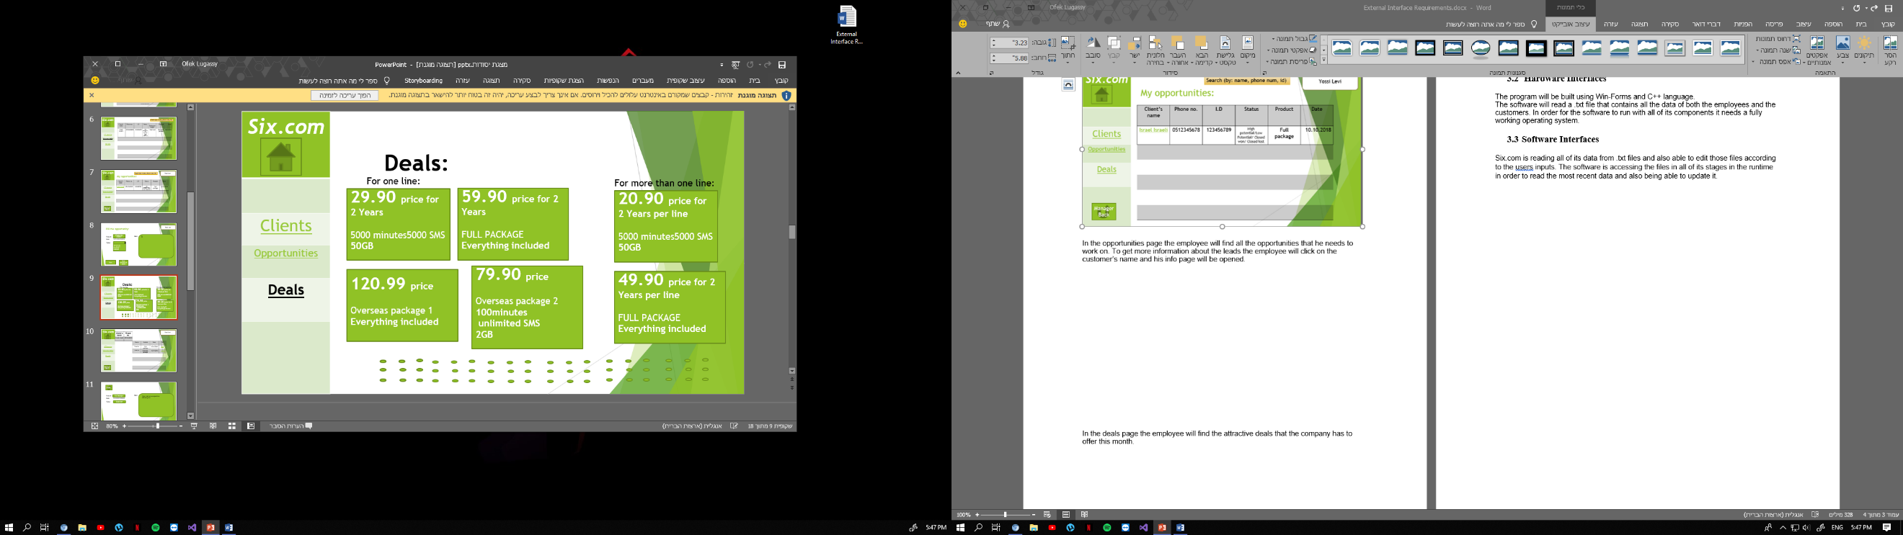

In the deals page the employee will find the attractive deals that the company has to offer this month.

## Hardware Interfaces

Since the application must run over the internet, all the hardware shall require to connect internet will be hardware interface for the system. As for e.g. Modem, WAN – LAN, Ethernet Cross-Cable.

## Software Interfaces

Six.com is reading all of its data from .txt files and also able to edit those files according to the users inputs. The software is accessing the files in all of its stages in the runtime in order to read the most recent data and also being able to update it.

# System Features

Six.com functional requirements that will built for the product are:

**candidates’ requirements:**

- register to the system.

- log in the system

**Six.com requirements:**

- Register to the system.

- Log in the system

- Possibility to add new client to the client's database in the system.

- Possibility to add a sale opportunity for a client.

- Possibility to see the details of all the clients stored in the system.

- Possibility to see the details of all the opened sales opportunities.

- Search for client according to name, id or phone num.

- Employee can see the list of sales opportunity of an existing client.

- Employee can see all the opportunities opened by him.

- Manager can add an employee to the employee's database.

- Manager can see the details of all the employees stored in the system.

- Manager can change activation status of a client.

- Manager can see the opportunities opened by a particular employee.

- Possibility to edit an opportunity.

## System Feature

**ID: FR1**

TITLE: User registration

DESCRIPTION: The user should be able to register through the system. The user must provide user-name and password.

RAT: In order for a user to register to the system

DEP: The system should have client's database.

**ID: FR2**

TITLE: User log-in

DESCRIPTION: Given that a user has registered, then the user should be able to log in to the system.

STIMULATE: The employee should fill the fields of user name and password. The system checks if find match to the data in the employee's database. If the data entered by the employee does not match the information stored in the system, an error message will be displayed and the employee will have to enter the details again.

RAT: In order for a user to log in.

DEP: FR1

**ID: FR3**

TITLE: Adding client

DESCRIPTION: The user can add a new client to the clients list.

STIMULATE: The homepage has a client+ button. By clicking on this button, will be open a screen with all the clients' details that the employee should fill out: name, phone, ID, email and customer status. The system will check the validity of the details entered. If the entered data is incorrect, an error message will be displayed and the employee will be forced to re-enter the incorrect details entered. If all the values entered is ​​correct, the client will be added to the clients list stored in the system database.

RAT: In order for a user to add new client to the database.

DEP: FR1, FR2.

**ID: FR4**

TITLE: Adding sale opportunity.

DESCRIPTION: A user should be able to add sale opportunity to a client.

SIMULATE: The customer list screen has a button that allows to add an opportunity to a certain client. The employee must fill in the details of the sale opportunity: selecting a product from the list of deals kept in the system, filling the status and adding a note if necessary. User will be able to define the status. There are four kinds of statuses: high potential (the client shows great interest in purchasing package), low potential (the probability of closing the deal is low), closed won (client successfully closed), and closed lose (client who identified as not interested).

The user will be able to choose the sale success percentage, which will be decided by user according to conversation with client.

When the data saves, the opportunity is added to the opportunities list.

RAT: In order for a user to add new sale opportunity to a client who want to make deal.

DEP: FR1, FR2, FR3.

The system should contain database for all the opportunities which added.

**ID: FR5**

TITLE: Showing clients list

DESCRIPTION: The user can see the details of all the clients who have been added to the system.

SIMULATE: By selecting the clients list option on the homepage, a screen will open with all the client details stored in the system. The user can sort all the clients by clicking on a client's name or status.

RAT: In order for a user to seek for a client.

DEP: FR1, FR2, FR3

**ID: FR6**

TITLE: Showing sale opportunities.

DESCRIPTION: The user can see the details of all the leads opened by all other users.

SIMULATE: There is possibility to click on the opportunity list button which displays the details of all the opened opportunities and shows the status of each of them.

RAT: Allows the employee and manager to follow opportunities, and to continue handle unclosed opportunities.

DEP: FR1, FR2, FR4, FR5.

**ID:FR7**

TITLE: Searching for client according to name, id or phone num.

DESCRIPTION: The system enables the user to find a certain customer in the clients list by entering a customer name, id or phone number. By clicking to the field of clients' name, they will be sorted in alphabetical order.

SIMULATE: In the clients list the user can search for a specific client by entering a value in one of the search fields: name, ID number or phone number.

RAT: In order for a user to search client.

DEP: FR1, FR2, FR5.

**ID:FR8**

TITLE: Showing all the opportunities of a client.

DESCRIPTION: The user can see the details of all opportunities opened to a particular client, and also can view the note that was added to specifically opportunities.

RAT: The system makes it possibility the user to follow the history of the clients, thus knowing better what deal to offer them.

DEP: FR1, FR2, FR5, FR6.

**ID:FR9**

TITLE: View opportunities opened by a particular employee.

DESCRIPTION: User can see the details of all his own opportunities, and the details of the clients to whom these opportunities are associated .This list user can sort be name or make the search by I.D, phone number.

SIMULATE: On the home page, the employee can choose the option to see all the opportunities he has opened. The system identifies these opportunities by the employee who logged into the system.

RAT: In order for a user to follow his opportunities and to contact the clients whose opportunities were not closed if necessary.

DEP: FR1, FR2, FR5, FR6.

**ID:FR10**

TITLE: Adding employee.

DESCRIPTION: A manager should be able to add employee to the database.

SIMULATE: If the manager logs on, he has the button of add employee. Selecting this option will open a screen with the employee's details that the manager should fill out: name, ID and phone number. The system will check the integrity of the data, and if they are correct the employee will be added to the employees list stored in the database.

RAT: In order for a manager to add new employees to the system.

DEP: FR1, FR2.

**ID:FR11**

TITLE: Showing employees list.

DESCRIPTION: The manager can see the details of all the employees who have been added to the system.

SIMULATE: The manager can view the details of all employees who are stored in the system database. In addition, he will be able to see how many opportunities were successfully closed by each of the employees.

RAT: The manager can follow the amount of opportunities each employee has managed to close successfully.

DEP: FR1, FR2, FR5, FR6.

**ID:FR12**

TITLE: Changing activation status.

DESCRIPTION: The manager can change the activation of a certain client. The manager can view the clients list stored in the system, search for a particular customer by name or phone, and change his activate if he decides to do so. The active status divided to three options: active (if it is an active client in the company), non-active (if the client is frozen) or blocked.

RAT: In order for a manager to change client's status.

DEP: FR1, FR2, FR5.

**ID:FR13**

TITLE: Showing opportunities that were opened by an employee.

DESCRIPTION: The manager can see the details of all opportunities opened by a selected employee.

SIMULATE: The manager can see the details of all the opportunities. By clicking on the employee's name associated with a certain opportunity, the manager will be able to see all opportunities that this employee has opened.

RAT: Allows the manager to view the details of all opportunities, as well as the opportunities of a specific employee.

DEF: FR1, FR2, FR5, FR6, FR11.

**ID:FR14**

TITLE: Edit an opportunity.

DESCRIPTION: The user can change the status and add an additional note for the opportunity. If the user changes the client's status, he should add a note for the reason of the changing. The date of an opportunity is the date of the last edit.

SIMULATE: The user can see all the opportunities of a certain client. For each opportunity there is an option of edit. The user can change the sales opportunity's status and percentage, also he can add a note to document the conversation.

RAT: Allow the user to edit a client's opportunity.

DEF: FR1, FR2, FR4, FR6.

# 5. Other Nonfunctional Requirements

## Performance Requirements

*The requirements in this section provide a detailed specification of the user interaction with the software and measurements placed on the system performance. The search feature should be prominent and easy to find for the user that’s means the different search options should be evident, simple and easy to understand.

*The results displayed in the list view should be user friendly and easy to understand. Selecting an element in the result list should only take one click.

*Cause the system works due to internet connection, if the system loses the connection to the Internet or the system gets some strange input, the user should be informed.

*The response time is significant part. After the search click the expected response time is no more than 1seconds at the pick time. The response time of the system for saving new client or new employee will be less than one second 95% of the time.

# *Scalability Requirements- Scalability is the ability of a system to grow in its capacity to meet the rising demand. As a raising company the system will be able contain up to 35 representatives at the same time without braking system.

## Safety Requirements

SAFETY-The degree to which a software system prevents harm to people or damage to the environment in the intended context of use. If there is extensive damage to a wide portion of the database due to catastrophic failure, such as a disk crash, the recovery method restores a past copy of the database that was backed up to archival storage. The access to the “backstage” (the code) of the system will have only developers of the current system and will use an access only for improve of the current code without harming the current data base.

## Security Requirements

*ACCESS SECURITY- extent to which the system is safeguarded against deliberate and intrusive faults from internal and external sources. The access permissions for system data may only be changed by the system’s data administrator. The user will connect with his personal password and only seller representative or sales department manager will have an access to client’s details.

*Only manager will have an access to block or freeze an active client and to add the new seller representative to the system.

*If a user wants to create an account and the desired user name is occupied, the user should be asked to choose a different user name. The seller representative should not be able to log-in for a certain time period after three times of failed log-in attempts.

\***Secure Sockets Layer** (**SSL**), are [cryptographic protocols](https://en.wikipedia.org/wiki/Cryptographic_protocol) designed to provide [communications security](https://en.wikipedia.org/wiki/Communications_security) over a [computer network](https://en.wikipedia.org/wiki/Computer_network) will be used to protect the clients details.

## Software Quality Attributes

\***Accessibility**-the system in its every page have an access and convenient option to go through existing clients and checking their activity and interest in different products and this way prevent excessive questioning and reduce conversation time.

* [**Maintainability** –the maximize simplicity of designing and planning the software will allow quick and harmless technical support to the regular work. More over system will be flexible and able to cope with a changed environment.](https://en.wikipedia.org/wiki/Maintainability) The application should be easy to extend. The code should be written in a way that it favors implementation of new functions.

* **Simplicity-** as stated above, software was planned and designed by simple and convenient way to understanding. For new employee there are all opportunities to stark working with the system from the first day.

* **Manageability- new software offers an option to separate manager access in order to prevent unwanted and unexpected changes. Moreover, the separated access open additional management option as adding the new worker and blocking clients.**

## Business Rules

The system must have at least a Super-User role and a User role defined for accessing and interacting with the system. Additional roles may be defined for the system as long as the business rules for the administrator and user roles are satisfied. The system was designed to give a work platform to seller representatives and to manage them as well.

Appendix A: Glossary

|  |  |
| --- | --- |
| **Term** | **Description** |
| System performance | Is the amount of work accomplished by the system |
| Response time | The time a generic system or functional unit takes to react to a given input |
| SSL | The most popular and important security of a web network. |
| Quality attributes | [Non-functional requirements](https://en.wikipedia.org/wiki/Non-functional_requirements) used to evaluate the performance of a system |
| Requirement | A number of units which must be fulfilled by one or more deals. |
| Product Scope | The features and functions that characterize a product, service, or result |
| Client | A computer or program that can run applications or request application-based services from a server. |
| Server | A computer that processes requests for data and Queries that are elements of the application |
| Cloud server | Is powerful physical or virtual infrastructure that performs application- and information-processing storage. |
| Web server | Is a program that uses [HTTP](https://searchwindevelopment.techtarget.com/definition/HTTP) (Hypertext Transfer Protocol) to serve the files that form Web pages to users, in response to their requests, which are forwarded by their computers' HTTP clients |
| Operating environment | Is the [environment](https://en.wikipedia.org/wiki/Deployment_environment) in which users run [application software](https://en.wikipedia.org/wiki/Application_software). |
| Alphabetical order | Is a system whereby [strings](https://en.wikipedia.org/wiki/Character_string) of [characters](https://en.wikipedia.org/wiki/Character_(symbol)) are placed in order based on the position of the characters in the conventional ordering of an [alphabet](https://en.wikipedia.org/wiki/Alphabet). |

Acronyms:

TBD: To Be Determined.

S .O: Sales Opportunity.

GNU: General Purpose License.

[HTTP](https://searchwindevelopment.techtarget.com/definition/HTTP): Hypertext Transfer Protocol.

Appendix B: Analysis Models

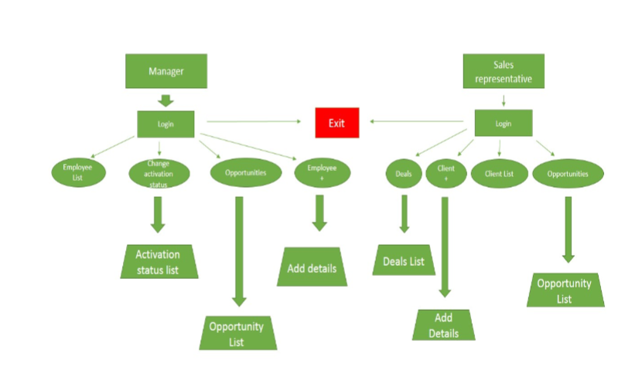

**Appendix C: To Be Determined List**

This To Be Determined (TBD) list serves to collect all currently outstanding decisions, choices, and unresolved requirements, including questions the development team may need to ask of the SixComServices. Presently there are no remaining TBDs. All TBDs have been tracked to their closure.